3.3 I can select and use appropriate tools to upload and publish the website

I downloaded Filezilla and selected my files to view them on there.

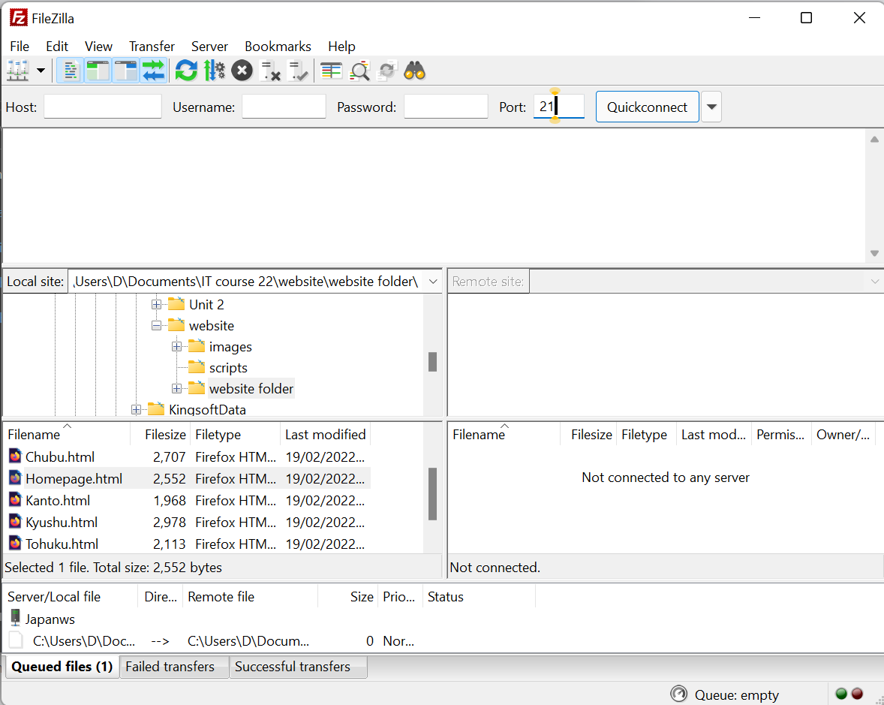

[The Above image shows Filezilla open on my computer and the files in the file window]